-- Stored function for addition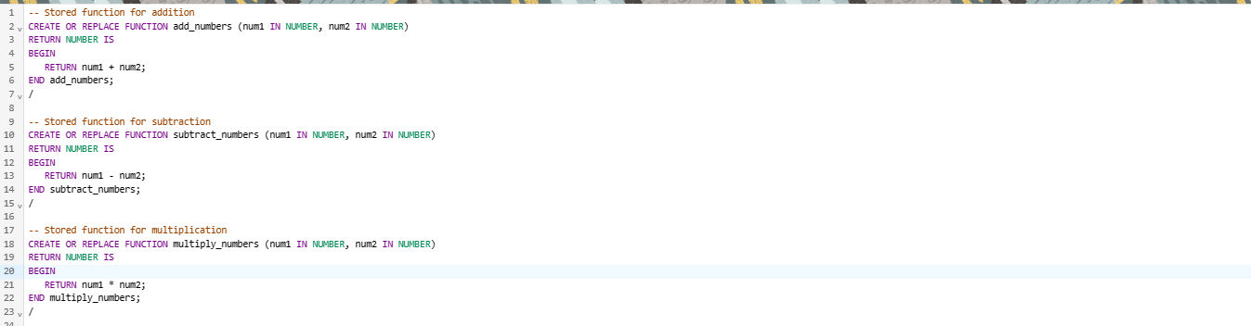

CREATE OR REPLACE FUNCTION add_numbers (num1 IN NUMBER, num2 IN NUMBER)

RETURN NUMBER IS

BEGIN

RETURN num1 + num2;

END add_numbers;

/

-- Stored function for subtraction

CREATE OR REPLACE FUNCTION subtract_numbers (num1 IN NUMBER, num2 IN NUMBER)

RETURN NUMBER IS

BEGIN

RETURN num1 - num2;

END subtract_numbers;

/

-- Stored function for multiplication

CREATE OR REPLACE FUNCTION multiply_numbers (num1 IN NUMBER, num2 IN NUMBER)

RETURN NUMBER IS

BEGIN

RETURN num1 * num2;

END multiply_numbers;

/

-- Stored function for division

CREATE OR REPLACE FUNCTION divide_numbers (num1 IN NUMBER, num2 IN NUMBER)

RETURN NUMBER IS

BEGIN

IF num2 = 0 THEN

RETURN NULL; -- To avoid division by zero

ELSE

RETURN num1 / num2;

END IF;

END divide_numbers;

/

-- Main Procedure

CREATE OR REPLACE PROCEDURE perform_operations (

num1 IN NUMBER,

num2 IN NUMBER) IS

-- Local function for addition

FUNCTION local_add (n1 IN NUMBER, n2 IN NUMBER) RETURN NUMBER IS

BEGIN

RETURN n1 + n2;

END local_add;

-- Local function for subtraction

FUNCTION local_subtract (n1 IN NUMBER, n2 IN NUMBER) RETURN NUMBER IS

BEGIN

RETURN n1 - n2;

END local_subtract;

-- Local function for multiplication

FUNCTION local_multiply (n1 IN NUMBER, n2 IN NUMBER) RETURN NUMBER IS

BEGIN

RETURN n1 * n2;

END local_multiply;

-- Local function for division

FUNCTION local_divide (n1 IN NUMBER, n2 IN NUMBER) RETURN NUMBER IS

BEGIN

IF n2 = 0 THEN

RETURN NULL; -- To avoid division by zero

ELSE

RETURN n1 / n2;

END IF;

END local_divide;

BEGIN

-- Call the local functions

DBMS_OUTPUT.PUT_LINE('Addition (Local): ' || local_add(num1, num2));

DBMS_OUTPUT.PUT_LINE('Subtraction (Local): ' || local_subtract(num1, num2));

DBMS_OUTPUT.PUT_LINE('Multiplication (Local): ' || local_multiply(num1, num2));

DBMS_OUTPUT.PUT_LINE('Division (Local): ' || local_divide(num1, num2));

-- Call the stored functions

DBMS_OUTPUT.PUT_LINE('Addition (Stored): ' || add_numbers(num1, num2));

DBMS_OUTPUT.PUT_LINE('Subtraction (Stored): ' || subtract_numbers(num1, num2));

DBMS_OUTPUT.PUT_LINE('Multiplication (Stored): ' || multiply_numbers(num1, num2));

DBMS_OUTPUT.PUT_LINE('Division (Stored): ' || divide_numbers(num1, num2));

END perform_operations;

/

EXEC perform_operations(10,20);